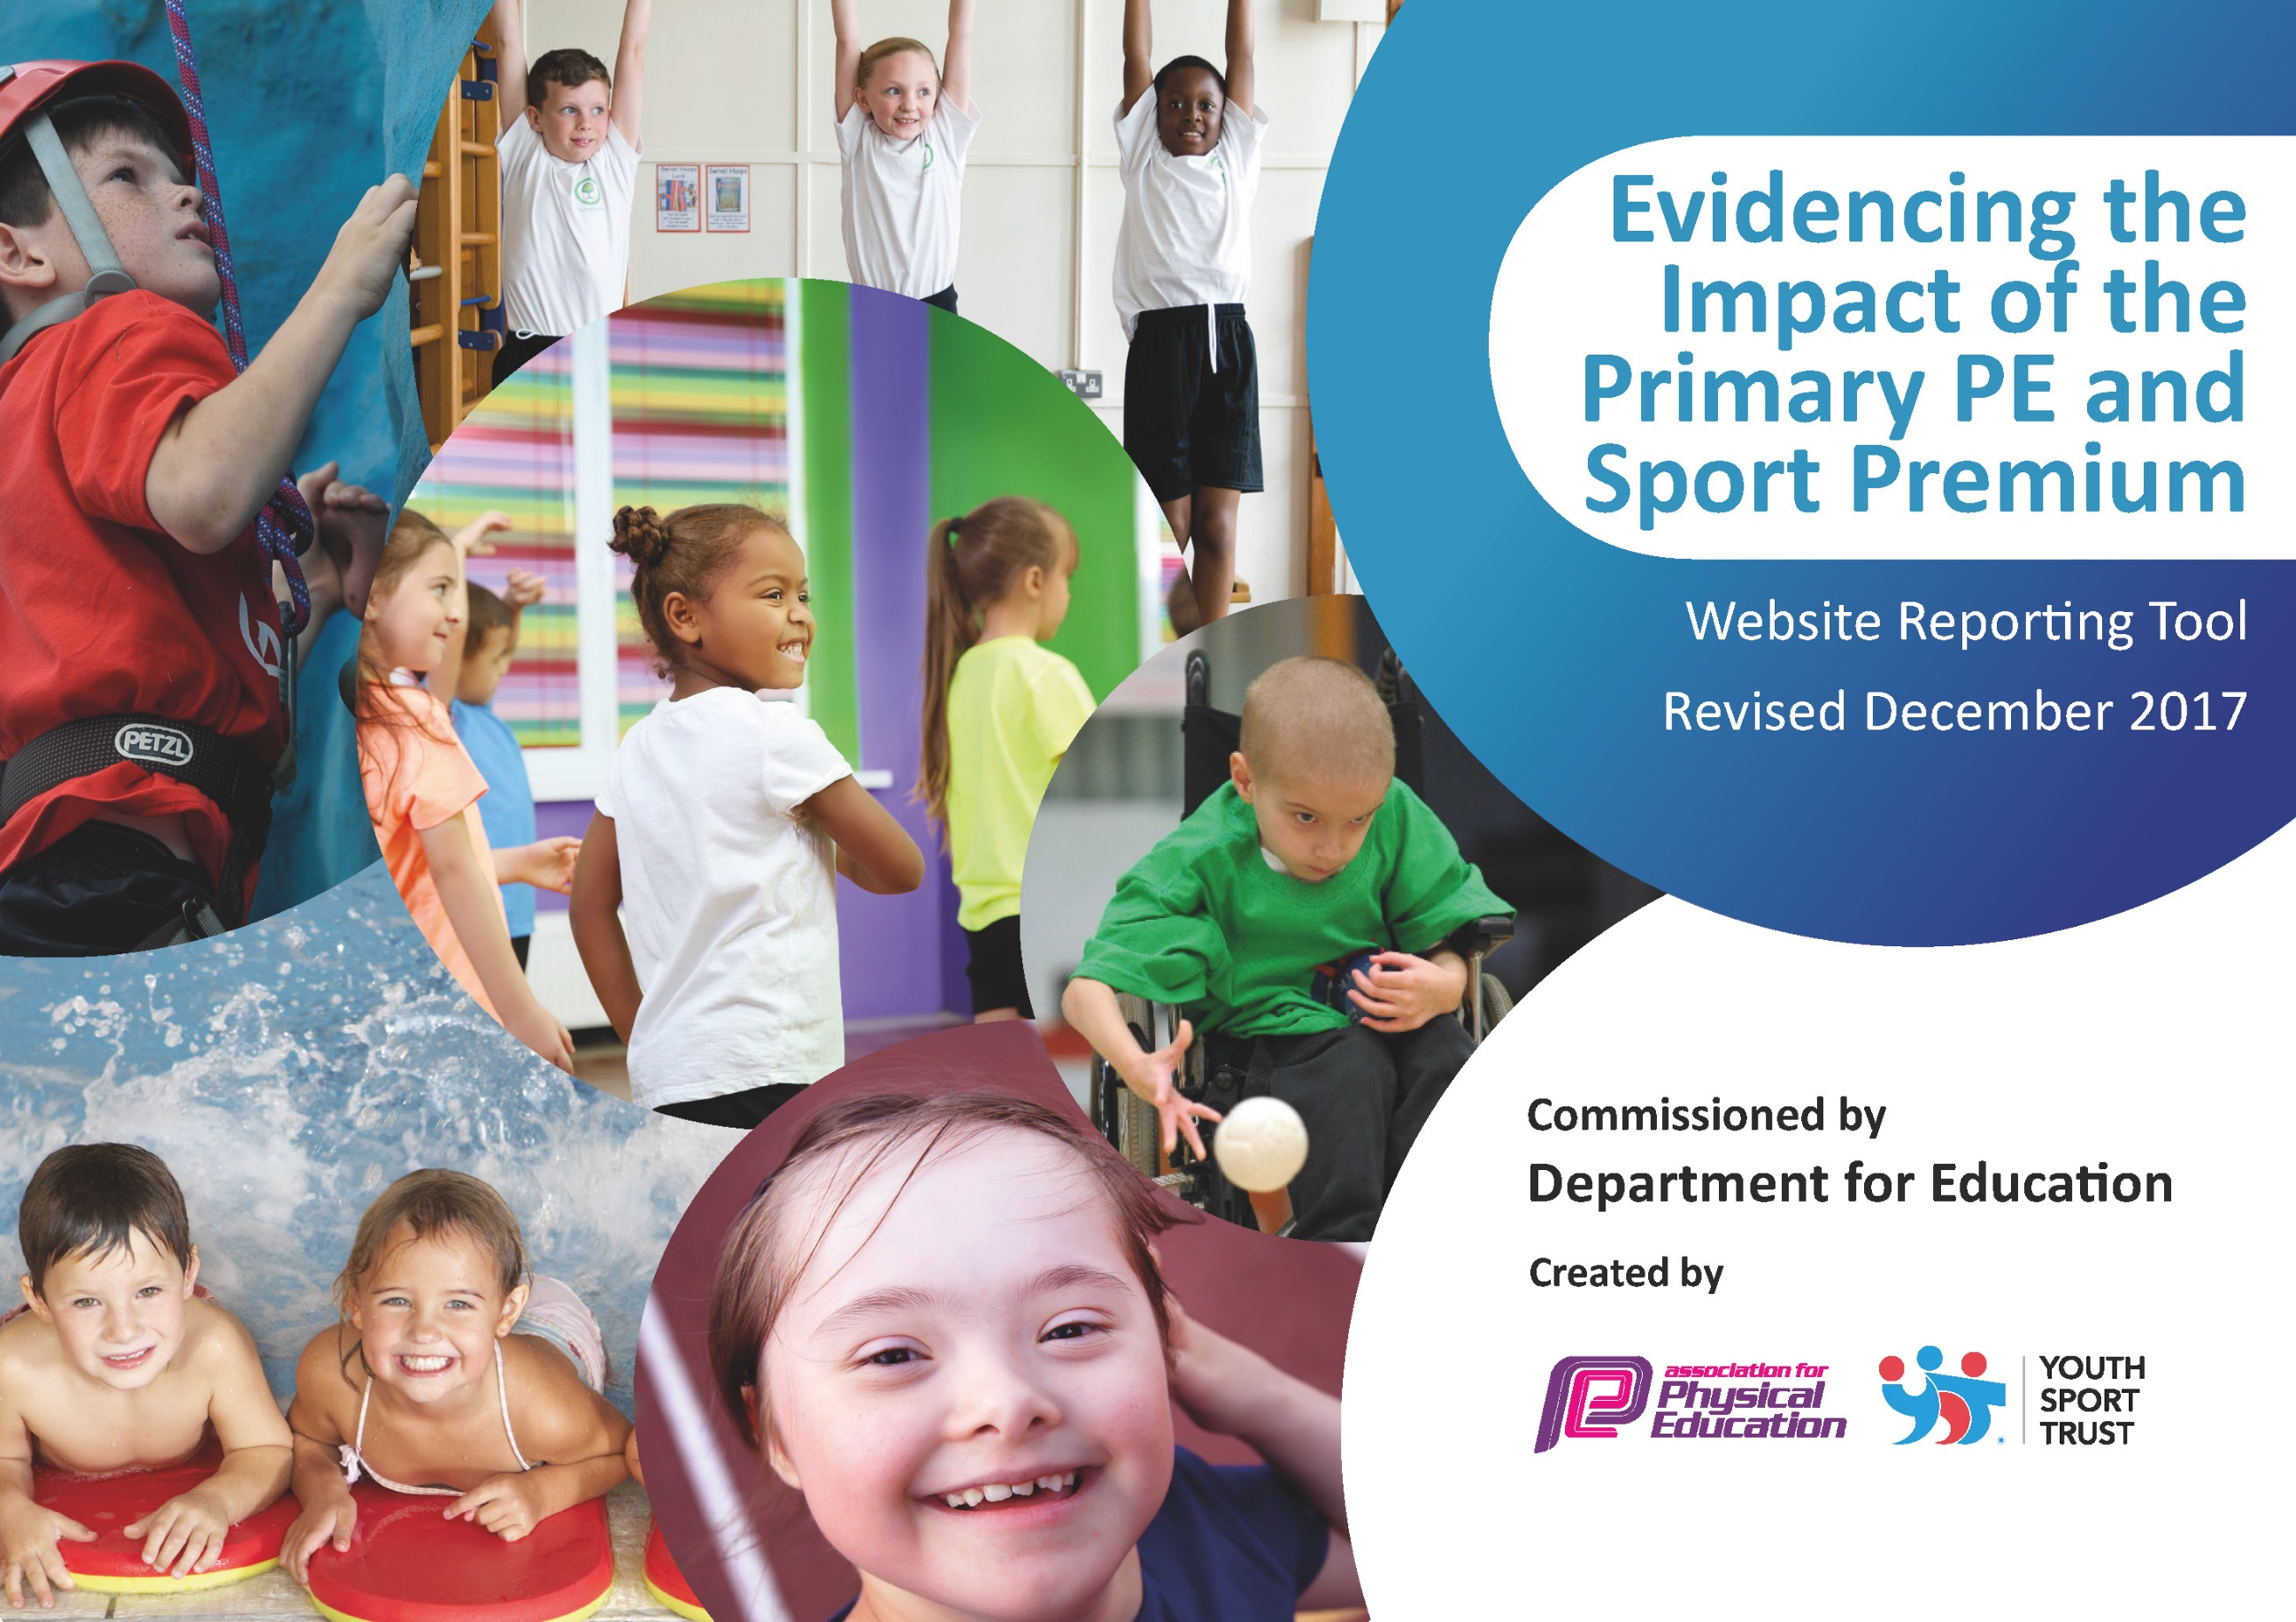

Schools must use the funding to make additional and sustainable improvements to the quality of PE and sport they offer. This means that you should use the Primary PE and Sport Premium to:

- develop or add to the PE and sport activities that your school already offers
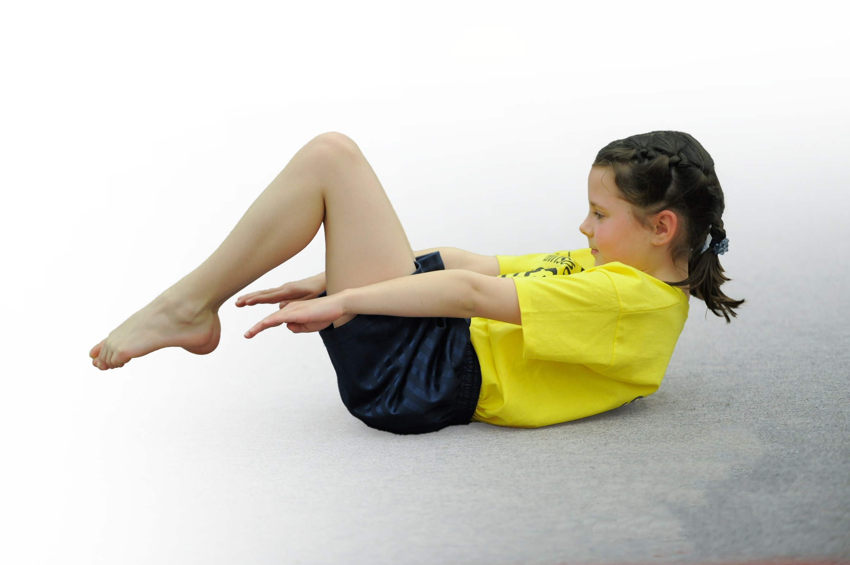
- build capacity and capability within the school to ensure that improvements made now will benefit pupils joining the school in future years

Please visit gov.uk for the revised DfE guidance including the 5 key indicators across which schools should demonstrate an improvement. This document will help you to review your provision and to report your spend. DfE encourages schools to use this template as an effective way of meeting the reporting requirements of the Primary PE and Sport Premium.

We recommend you start by reflecting on the impact of current provision and reviewing the previous spend.
Under the Ofsted Schools Inspection Framework, inspectors will assess how effectively leaders use
the Primary PE and Sport Premium and measure its impact on outcomes for pupils, and how effectively governors hold them to account
for this.

Schools are required to publish details of how they spend this funding as well as on the impact it has on pupils’ PE
and sport participation and attainment.
We recommend regularly updating the table and
publishing it on your website as evidence
of your ongoing review into how you are using the money
to secure maximum, sustainable impact. To see an example of how to complete the table please click HERE.

Support for review and reflection - considering the 5 key indicators from DfE, what development needs are a priority for your setting and your students now and why? Use the space below to reflect on previous spend, identify current need and priorities for the future.

Key achievements to date: | Areas for further improvement and baseline evidence of need:
- All EYFS children in 2017/18 achieved the expected standard in the Physical Development ‘Moving and Handling’ Early Learning Goal, with 12/40 exceeding the expected standard.  - A PE assessment tool continues to be used for both KS1 and KS2 children. The assessment shows clear progression over both key stages and also is helpful in identifying where any gaps in learning are. Data received suggests that the vast majority of children are ‘on-track’ in their PE ability, with most Year 6 children achieving all objectives and all Year 6 children achieving at least 11/18 objectives.  - At the end of the 2017-2018 academic year, 40/42 children reached the expected standard for swimming.  - Level 1 (intra-school) competitions were held in Cross Country and Multi-skills.  - Training for competitive sport was provided throughout the year both within and outside of PE lessons. Talented children were identified during these sessions and were often offered further training prior to them being invited to represent the school in Level 2 competitions. Children who showed promise in Dance sessions were invited to audition for a Dance Academy, linked to ‘The D Project’, who run our after school Dance sessions.  - Children enjoyed a high level of success in many of the sporting competitions they entered last year:  *Medals were awarded in Cross Country, Swimming and Gymnastics events. Children competing in the Athletics events achieved individual success but also achieved gold team medals.  *A number of children were then invited to take part in Level 3 (Tees Valley) competitions for these sports, with some children winning medals at these events too.  - Children in various year groups trained to take part in the Darlington Dance Festival, the Darlington Mass Dance and the Darlington Community Games, all non-competitive events.  - A ‘skipping day’ was organised to encourage children to engage in new skills. Each class spent 45 minutes with a coach to take part in a skipping session which seemed to enthuse many, as lots of children they began to bring skipping ropes in to play with during break times.  - All children across the school participated in a sponsored bike and scooter day, raising money for a local charity.  - All reception children took part in 5 sessions of cycling lessons, provided by British cycling.  - EYFS/KS1 and KS2 sports days were very successful, involving all children regardless of ability and engaging parents to come and support school events.  - A range of sporting before and after school clubs were successfully provided for all age groups, both inside and outside of the school grounds. 75% of children in school took part in at least one half term of extra-curricular sports sessions, including over half of children identified as ‘less-active’ the previous academic year.  - The school achieved the nationally recognised Silver School Games Mark award in recognition of our high quality PE and sports provision. | - Playground markings currently do not encourage playtime activity. New markings would help children to complete their ’30 Active Minutes’ a day.  - Sports leadership training for older children would be useful in encouraging others to take part in sporting activity throughout the school day.  - A full PE ‘Health Check’ would be a useful tool in determining the steps we need to take to improve our PE provision and guarantee the best possible way to spend our Sports Premium money.  - Two Year 6 children did not achieve the ‘expected’ standard in swimming last year. It is possible that extra swimming tuition, paid for with Sports Premium money, could be provided for children struggling with their swimming skills through the School Sports Partnership.

Meeting national curriculum requirements for swimming and water safety | Please complete all of the below*:
What percentage of your current Year 6 cohort swim competently, confidently and proficiently over a distance of at least 25 metres? | 97.4% (January 2019)  38/39
What percentage of your current Year 6 cohort use a range of strokes effectively [for example, front crawl, backstroke and breaststroke]? | 97.4% (January 2019)  38/39
What percentage of your current Year 6 cohort perform safe self-rescue in different water-based situations? | 97.4% (January 2019)  38/39
Schools can choose to use the Primary PE and Sport Premium to provide additional provision for swimming but this must be for activity over and above the national curriculum requirements. Have you used it in this way? | Yes
*Schools may wish to provide this information in April, just before the publication deadline.

Action Plan and Budget Tracking
Capture your intended annual spend against the 5 key indicators. Clarify the success criteria and evidence of impact that you intend to measure to evaluate for students today and for the future.

Academic Year: 2018/19 | Total fund allocated: £18, 540 | Date Updated: January 2019
Key indicator 1: The engagement of all pupils in regular physical activity – Chief Medical Officer guidelines recommend that primary school children undertake at least 30 minutes of physical activity a day in school |  |  |  | Percentage of total allocation:
 |  |  |  | 23% (minus apprentice costs)
School focus with clarity on intended impact on pupils: | Actions to achieve: | Funding allocated: | Evidence and impact: | Sustainability and suggested next steps:
Children to be provided with a range of activities they can take part in throughout the school day, both inside and outside of the classroom, to help them achieve their ‘Active 30 Minutes’. | Playground markings to be upgraded to include an ‘activity track’ for children to independently access during playtimes.  All class teachers to be provided with an ‘Activate’ DVD to encourage classroom movement breaks.  Lunchtime Supervisors, Sports Apprentice and a group of selected Year 4 children to be trained in leading playground games, which will be available to classes of children every day.  Staff Meeting to take place informing all staff about the ‘Active 30 Minutes’ agenda.  ‘Active Ted’ scheme to be bought into as a means of engaging children in activity both at home and at school. | £4000  £0  £348 ‘Active 30’ training  £7, 267 p.a (Apprentice costs)  £348 ‘Active 30’ training  £348 ‘Active 30’ training | All children will take part in at least 30 additional minutes of physical activity each day.  Evidence: Photographs  Active Ted tracker  ‘Activate’ record
Key indicator 2: The profile of PE and sport being raised across the school as a tool for whole school improvement |  |  |  | Percentage of total allocation:
 |  |  |  | 14%
School focus with clarity on intended impact on pupils: | Actions to achieve: | Funding allocated: | Evidence and impact: | Sustainability and suggested next steps:
We will aim to provide outstanding PE and Sport provision both inside and outside of lessons with the aim of encouraging all pupils to engage in active lifestyles. | A PE health check is to be conducted to identify where we can improve our practice and further support pupil achievement and engagement with PE and sport activities. | Included in our SLA agreement - £2550 | PE planning updated  Recommendations from health-check in place (reported on to AC members)

Key indicator 3: Increased confidence, knowledge and skills of all staff in teaching PE and sport |  |  |  | Percentage of total allocation:
 |  |  |  | 39% (minus SLA costs)
School focus with clarity on intended  impact on pupils: | Actions to achieve: | Funding  allocated: | Evidence and impact: | Sustainability and suggested  next steps:
Ensuring children’s previous skills in PE are built upon within lessons and that all children are enabled to perform to the best of their ability. | A package of CPD sessions has been bought into and all staff teaching PE will have access to at least five sessions of team teaching with a PE specialist with the aim of improving teacher confidence, knowledge and skills.  An apprentice is to be employed to support in all PE lessons and will be able to carry out a range of useful roles such as supporting individual or groups of children, evidencing skills or assessment. | Included in our SLA agreement - £2550  £7, 267
Key indicator 4: Broader experience of a range of sports and activities offered to all pupils |  |  |  | Percentage of total allocation:
 |  |  |  | 2%
School focus with clarity on intended  impact on pupils: | Actions to achieve: | Funding  allocated: | Evidence and impact: | Sustainability and suggested  next steps:
We will look to engage all children in activity, especially traditionally less active pupils, by providing a broad range of sports that they are able to access both inside and outside of the traditional school day. | Sporting Chance, who deliver two of our current after school clubs, are able to provide more ‘unusual’ sports such as archery and team games.  A date for a whole school sporting event has been arranged which will include children taking part in sports that are unfamiliar to them.  At least one ‘Outdoor and Adventurous’ school trip to be arranged per class, where possible. | TBC  £322.50  TBC | A wider variety of activities are offered after-school.  Whole school event
Key indicator 5: Increased participation in competitive sport |  |  |  | Percentage of total allocation:
 |  |  |  | 2%
School focus with clarity on intended  impact on pupils: | Actions to achieve: | Funding  allocated: | Evidence and impact: | Sustainability and suggested  next steps:
All children at various points in the year to be involved in competitive sport, both within and outside of lessons. Children will be trained and encouraged to compete to the best of their abilities which will improve the skills/times/distances that they achieve. | A whole-school intra-school competition has been arranged on top of the traditional intra-school activities we provide.  At least two, Level 2 competitions to be entered every term with some ‘B’ teams to be entered ensuring maximum participation.  A number of training sessions to be provided (including some off-site) for children selected to compete in Level 2 competitions.  Competitive events for children who are identified as ‘less-active’ (for example, Community Games) to be entered into.  A Key Stage 1 Level 2 competition to be entered into to encourage competitive sport at a young age. | £322.50  Included in our SLA agreement - £2550  TBC  Included in our SLA agreement - £2550  Included in our SLA agreement - £2550

